**User manual/ readme**

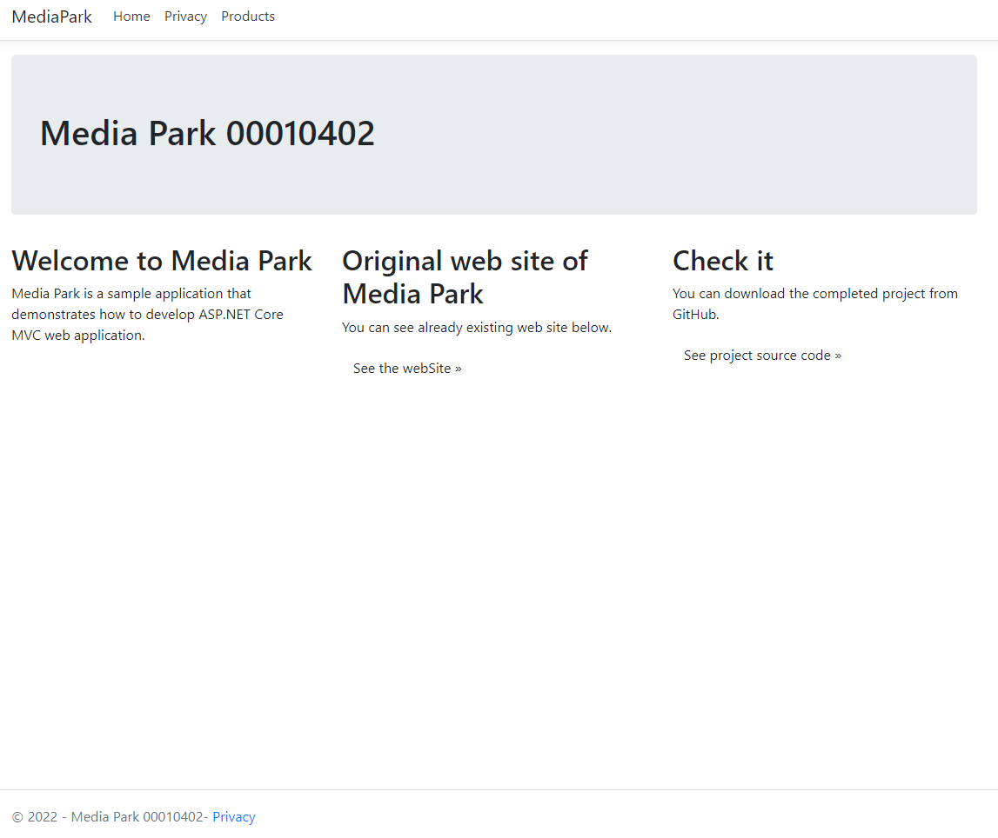

Here is home page as you can see all information Student ID and company Media Park. It was developed using ASP.net 5 MVC, bootstrap and angular. In home page, there are 3 links: Home, Privacy and Products.

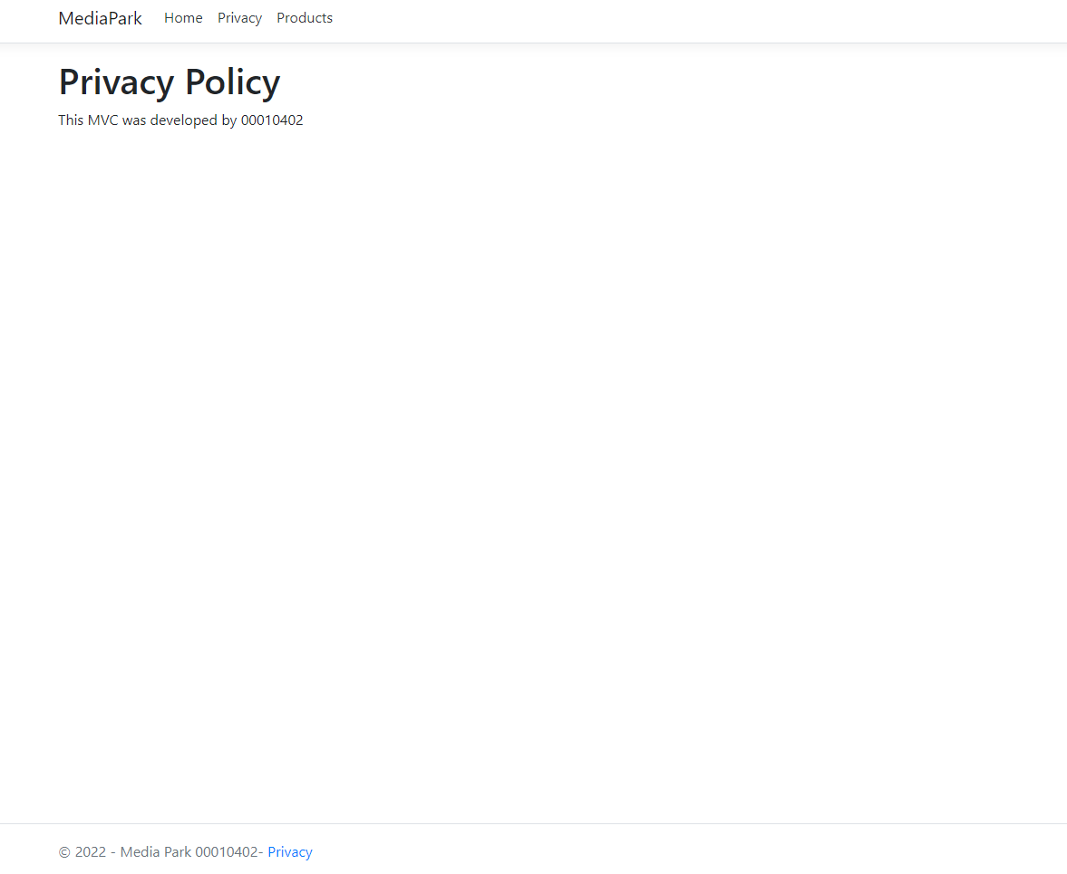It is Privacy page, and it is written by whom it was developed

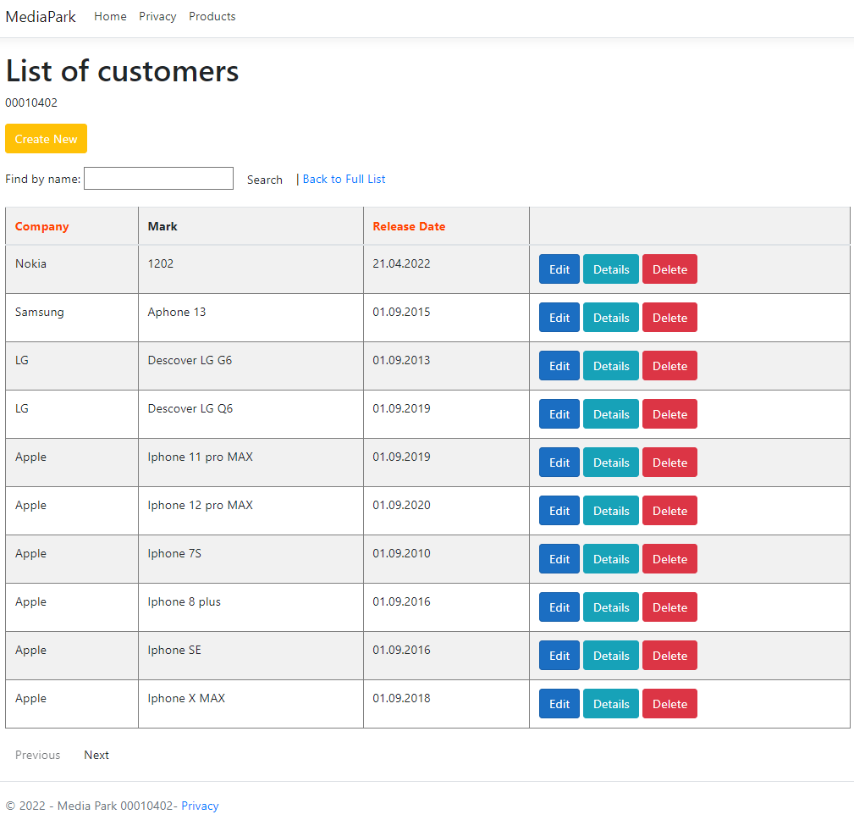

As we can see here is a lot of features such as: paging, sorting, filtering, creating, all data from database. We can Edit, see Details as well as delete the data.

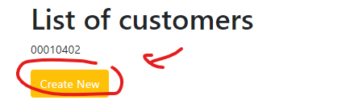

If we press this button, we will get create page

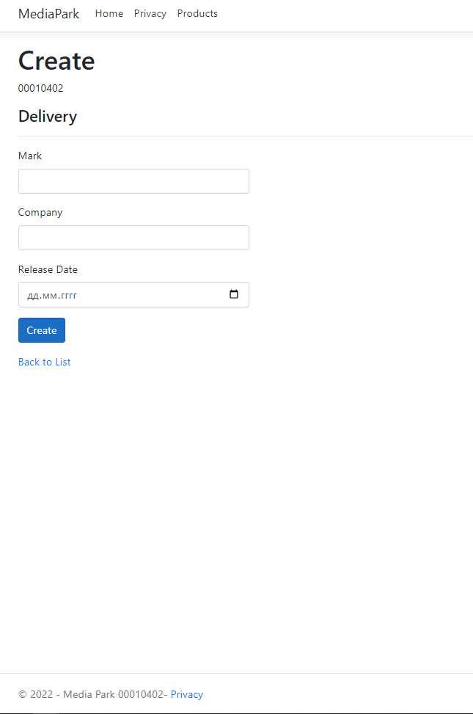

Create page has empty fields such as Mark, Company and Release Date. So in order to add new products we need to fill all those fields.

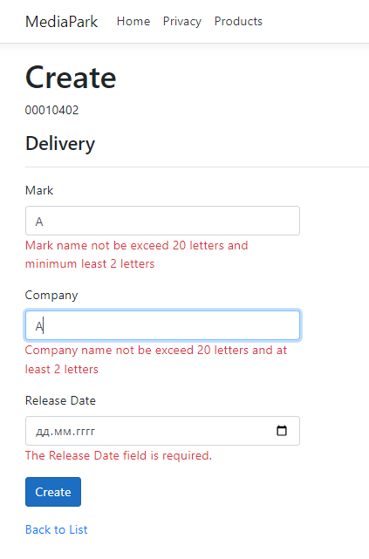

If we don’t fill the fields we can not add new product. So also there are some validations as it is written below for each fields. If we add successfully it will back to products list 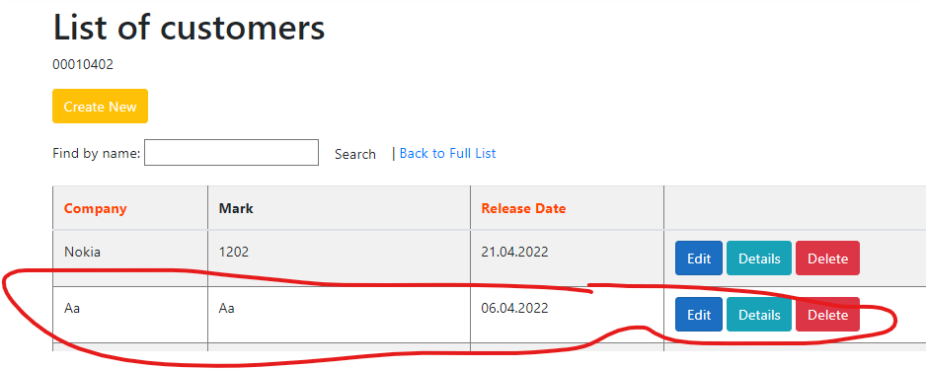

As we can see here is new product, which I add

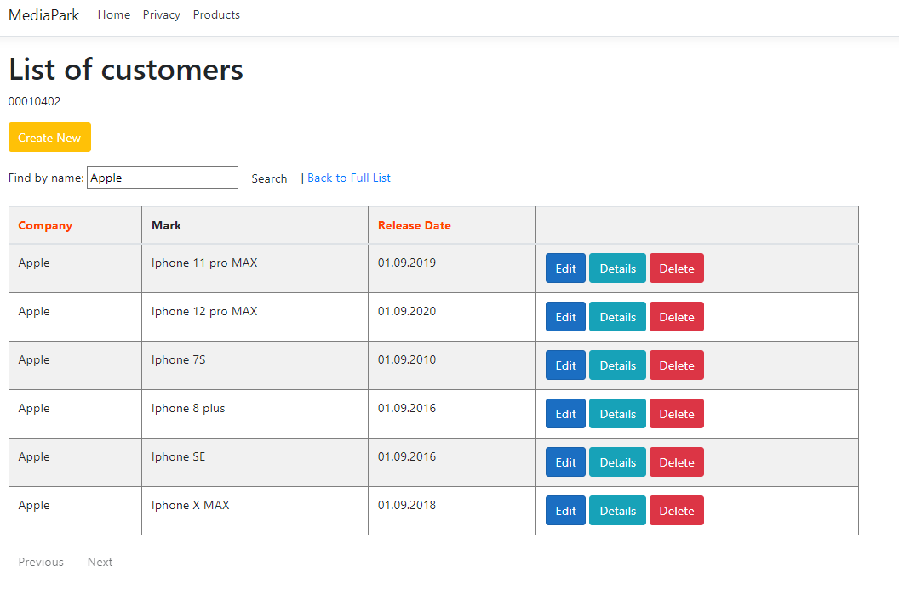

Moving to searching, here I tried to search only Apple products by company name (also we search by mark), as a results, we got all apple products.

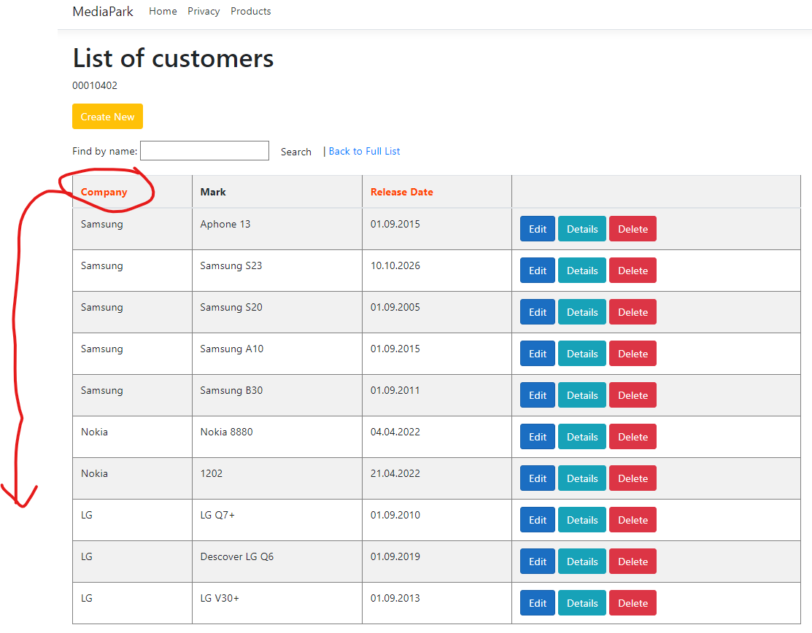

If we press Company it will sort by company name as we can see above. Also we can sort by release date working principle is the same with company sorting.

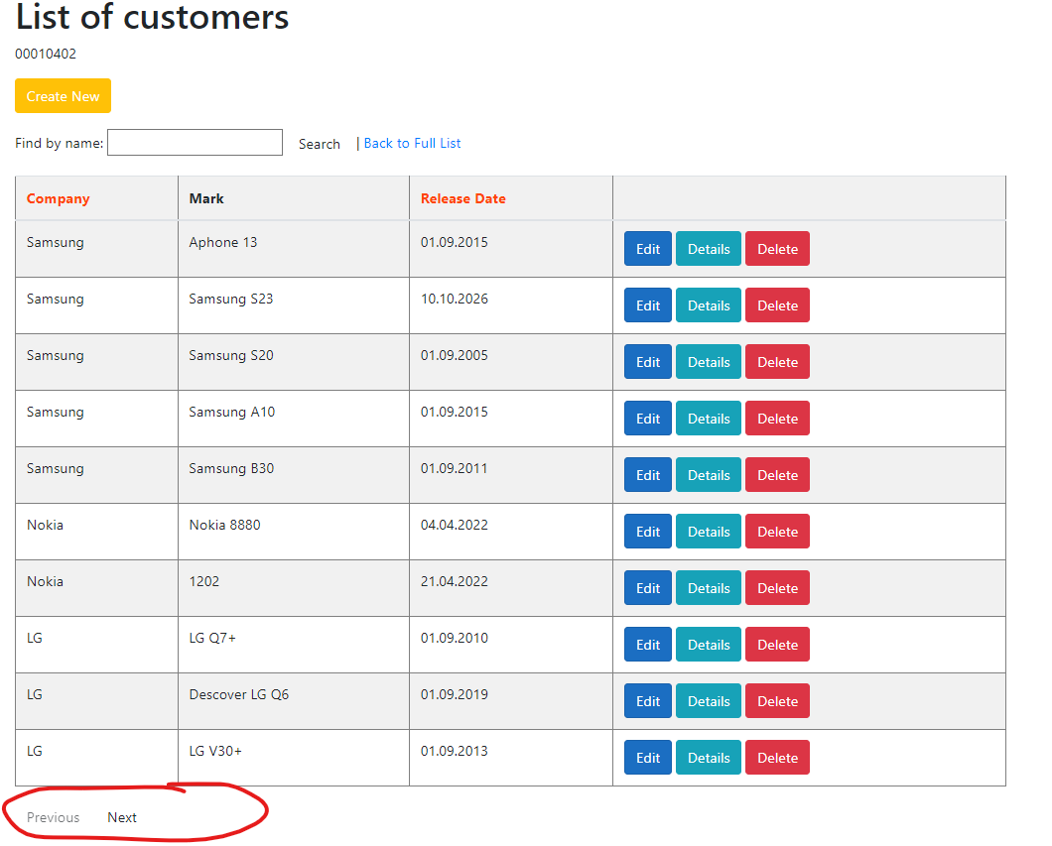

Above is about the paging, each page has max 10 products in the table, two buttons Next page and Previous page…

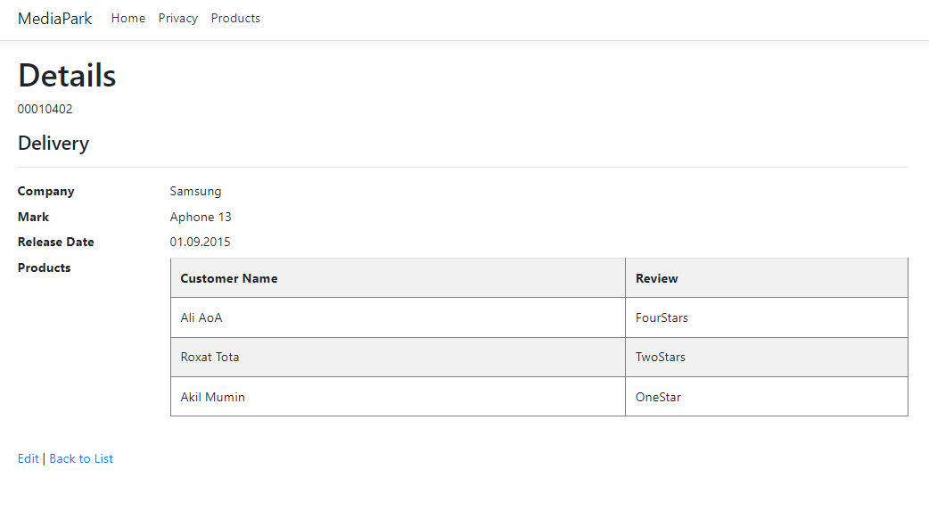

If we press to details, we will get Details page, as we can see we will get Details of this product such as Company, mark name release date and additional table. In this table we can see customer name who already purchased and rate of this product. And from this page we can Edit or back to full list.

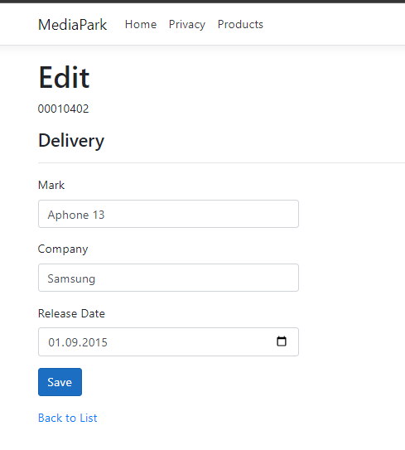

If we press Edit, here we go with full information and we can edit and save so it will update the list 4

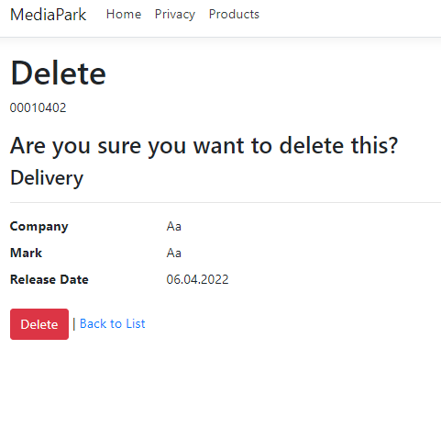

Here is delete Page, it asks the permition do you realy want to delete this product. If yes, it will delete and back to full list with updated table.